1. **Charter Schools are more successful in terms of overall passing (math’s/reading) compared to district school. This could be identified from the below trend**

Top 5 performing Schools

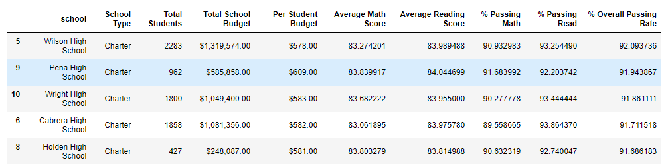 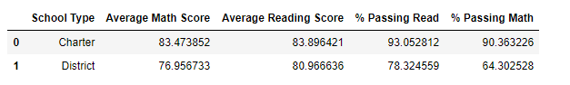

1. **Schools spend a higher budget on weaker students compared to bright ones**

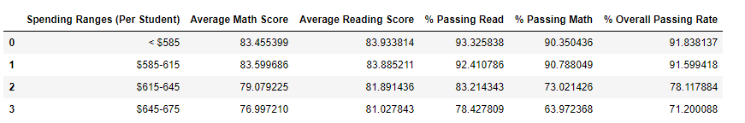

1. **Smaller the Size of the school better is the passing percentage in math’s/reading**

